**AUDEARA HEADPHONES**

**Introduction**:

Good Morning everyone, My name is Haley, and this is Maddy, Tina, John and Mikey. The company that we will be analysing today is Audeara headphones. This is our outline for today. And we’re just going to show a quick video to introduce the company for you.

**Project Summary- HALEY**

The problem:

Audeara are currently working towards gaining a greater share of the market and are particularly interested in attracting millennials – more specifically, university students. Clearly, they have some huge competition, with big players like Sony, Bose and Beats already dominating the market for headphones. Thus, one of their main concerns is how to position themselves against these rivals.

Audeara want to know how they can get their message across to their current target market of university students, and how they can influence them to buy into their products and brand over those of the big competitors in this highly rivalrous industry. I’ll hand over to Tina to further discuss this.

* **The Target Audience** related to project and problem identified: the customers - **Tina**

With the data the client concluded when they first launched the product to the market, Our client had summarized the current consumers are 70% of males aged from 25 – 35, who are very obsessed with well defined music /sounds quality. However, to further raise more awareness, it is also critical to tap into millennials generation aged from 18 - 24, as they are the largest demographic in the country. Therefore, we came to a conclusion that we will target University students specifically, as they have the longer-term potential for profits. They are also the biggest age group that are increasingly exposed to noise pollutions resulted from loud musics and the living environments around them. Therefore, it is essential to realize the importance of getting our brand in front of them at the early stage.**Change Slide**

* **Current situation/ Strategy-Tina**

The main current marketing strategies the client has applied to target the market are digital marketing. The client has covered most of the online marketing channels to target the current audiences, including social media marketing, content marketing, search marketing, online stream, and radio advertising, etc. which are all very effective in a way that it quickly target the consumers that would have the most interests in buying Audeara headphones. In addition to that, traditional marketing channels are also an important component of the formulation of strategies for Audeara to target consumers, including the press outreach, music & tech conferences, and professional networking events particularly for the hearing loss industries. **Change Slide**

Just for your better understanding why they are in the hearing loss industry, our client are one of the registered service providers for the National Disability Insurance Scheme -NDIS and they are also partnered up with Attune, which is a professional body for audiologists. Disable people with certain degree of hearing loss could get a pair from governments for free. Therefore, Audeara company not only present as entertaining consumer goods but also are positioned as a medical device for people in need.

Now i will pass it on to Mikey.**Change Slide**

**Competitive Positioning:**The global headphone market is split into three segments:  
1. In-ear headphones (like the apple earpods)   
2. On-ear headphones  
3. Over-ear headphones

The estimated 2016 market share between these 3 segments was:

In-ear = 56.44%

On-ear = 23.33%

Over-ear = 20.23%

(TechNavio, 2016)

Due to making only an over-ear product, you could say that Audearea’s biggest competitor is the in-ear market.

Auderea is firmly positioned at this current stage as a market “nicher” with a small but growing rate of sales and market share and a significant focus on being a feature specialist in their commitment to tailoring their products. This is where their competitive advantage lies.

**CHANGE SLIDE**

**Domestic Competitors:**

Two recent start-ups that are a ahead slightly of Audearea in competitive positioning in Australia:

1. Nura

* launched last year with $1 million in crowd-funding
* Market Follower to global brands
* Over Ear Focus
* (Eliezer, 2017)

1. Nuheara

* Also launched also year and set an Australian kickstarter record last year of $1.8 million.
* Market Nicher (Eliezer, 2017)
* Complex In-Ear focus - IQBuds product

**CHANGE SLIDE**

**Global Competitors**:

This matrix, showing the US wireless headphone market at the end of 2016, paints a clear picture of the dominance by Beats on an international stage.

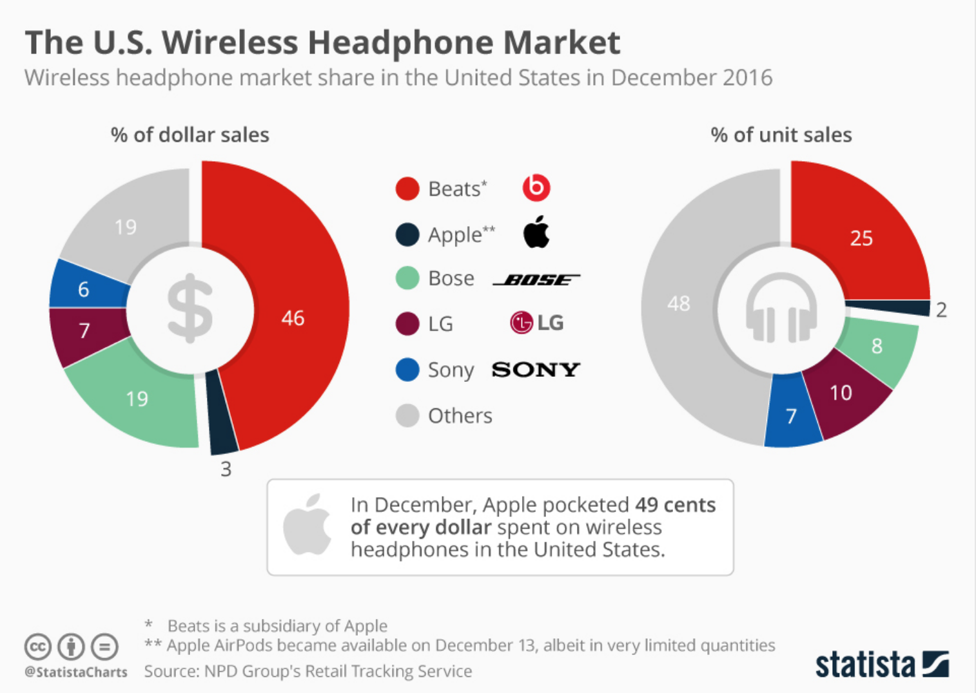

(Richter, 2017)

1. Beats/Apple

* Market Leader
* Apple purchased Beats in 2014 for $3billion
* 49% of US market share (Richter, 2017)
* Favoured by millenials
* Premium pricing

1. Sony & BOSE (Market Followers)

* Both are powerful global companies.
* Much larger range of headphones across the three segments ranging from low-premium prices.

**CHANGE SLIDE**

These are the models recognised as being in direct competition with Audera’s A-01 model. It can be seen here that Audera has a mid-range price compared to the rest of the market and the only product that provides a threshold hearing test and that tracks hearing health:

**Measurability:**

In terms of measurability, data collection in this case should be relatively straight forward. Upon any purchase a customer will provide a date of birth and an occupation. After executing our marketing strategy this data will be reviewed and compared to the previous time-frame to see whether our sales to the target demographic of uni students are increasing or not.

**Maddison**

When formulating our strategies for Audeara we wanted to combine the company’s weaknesses and opportunities together in order to make a strength for them in the future. From the SWOT analysis and Porter's five forces model we created, Audeara were the first in the market to bring out a highly innovative and sophisticated headphone. (CHANGE)

However, with a lack of brand awareness and trust they faced the threat of well established companies such as Sony and Beats.(CHANGE) Audeara has recently tried to establish brand trust by announcing giveaways on their Facebook page such as ‘subscribe to win a free pair of Audeara headphones”. However, we want to push it further we want everyone to know that ‘gone are the days of one sound fits all’ now it is ‘test your hearing. Tailor your sound’.

The other main weakness established which is a high deterrent, especially to university students is the price tag. Thus concludes our strategy formulation. Hayley will now discuss these strategies in further detail. (CHANGE)

**Recommendations (Haley):**

One major selling point for university students is price. We strongly believe that offering a 10% discount will make university students more likely to purchase Audeara headphones.

To further offset the concern of price, we also recommend that Audeara introduces the use of Afterpay to their online store. We believe that the ability for students to ‘buy now and pay later’ will increase willingness to purchase a product that may be out of the budget, but otherwise appealing.

In 2018, Audeara went to the music festival ‘Splendour in the Grass’ to further push their product. We believe that continuing to go to similar events will help to increase consumer awareness within their target market. In order to allow for the consumers to gain trust in the product, we propose that Audeara consider setting up a testing booth. This will allow passers-by to test their hearing and hear how the headphones compliment their hearing profile, thus increasing likelihood of purchase. We also recommend that Audeara consider utilising the testing booths at university open days as this will allow for direct exposure between uni students and the product.

Finally, the current appearance of the headphones is quite generic: all black with leather cushioning around the over-ear speaker. We believe that university students will find appeal in a larger range of colours, textures and sizes. However, our client from Audeara has asked to keep away from a ‘trendy’ brand personality and lean more towards an aura of sophistication, thus we will take this into consideration and further consult with them for ideas. I’ll now hand over to John.

* **Information required:** The information you don’t have but you identify you need to find - **John**

- statistic data which showing change economic flow of the world

(depends on the changing economic flow we have to set different strategy)

- prospect of headphone market trend

(expectation of market trend can suggest opportunity)

- brand awareness of customer

(How much the customer know about our brand it represent brand position. where our brand present location in market)

- news article cover our company

(know about media awareness to make proper positioning strategy)

- other company's problem solving example when face to similar problems

(Benchmarking other companies strategy)

- customers responses and feedback after use the product

(after apply the marketing strategy clients change in target market consumption and other follow-up action)

* **A project plan and timeline: - John** (around 1 minute 30 second)  
  Consists of 5 steps

1. Establish the marketing objective (project summary-target market and client, problem we have faced, desire outcome)
2. Market analysis and collect information (analyse 3 C’s of marketing (customer, competitor, awareness of customer, potential competitor, competency of our company) (consider income and consumption of target consumer) (major market trends)
3. Setting strategy. (Target market SWOT analysis) (Other strategy what we discussed in project specifics) (Possible benchmarking point from competitor)
4. Reviewing the strategy (missing point what we haven't discussed yet) (if sub problem occur how we resolve it) (expected situation after we implement strategy)
5. Implement the problem solution and expected result (evaluation) (outcomes of the project and change in market consumption) (other follow-up actions or amend point of project)

TechNavio. (2016). *Global Headphone Market 2017-2021* (Vol. 1). TechNavio

Richter, F., Mr. (2017, February 8). The U.S. Wireless Headphone Market. Retrieved August 18, 2018, from <https://www.statista.com/chart/7993/headphone-market-share/>

Eleizer, C., Mr. (2017, July 21). Music streaming driving growth of headphones market. Retrieved August 18, 2018, from https://themusicnetwork.com/music-streaming-driving-growth-of-headphones-market/

**Brief criteria**

**Student Name and Student ID No:**

* Haley Judge (44314318)
* Maddison Foskett (4433520)
* Michael Morrey (44350718)
* Hui Jong Lee (44065759)
* Ping Ma (44185639)

**Team Name:**

* Team Audeara

**Firm Name and details**

* Our chosen business – Audeara – is a recent start-up company that provide headphones with an inbuilt hearing test to measure your hearing and tailor the sound perfectly to each user and every ear. This idea came from seeing patients in the hospital – they wanted to make hearing tests more accessible for everyone as everybody hears things differently and has a different degree of hearing loss. With these headphones, users will be able to use the inbuilt medical audiogram to monitor how their hearing changes over time and continue to ensure that their hearing profile is being used to experience the true quality of their music.

**Project Name and summary:**

* Audeara headphones marketing brief. We will be discussing Audeara’s current strategy, the problem they are facing, our take on the problem, competitive positioning in the industry, the measurability of our project, strategy formulation, strategy recommendations, the information we require to implement these strategies, and the overall timeline for our project.

**Client and project description:**

* Audeara are currently working towards gaining a greater share of the market and are particularly interested in attracting millennials – more specifically, university students. Clearly, they have some huge competition, with big players like Sony, Bose and Beats already dominating the market for headphones.
* One of the main concerns for Audeara in their goal of attracting uni students is how to position themselves against these rivals to become a preference for these consumers. As their main source of competitive advantage is the way that their products care for and are tailored to your hearing, they need to be able to stress the importance of this, which may be quite difficult when the millennial attitude for such health issues is often ‘we don’t care’ or ‘it isn’t affecting me right now’. Thus, Audeara want to know how they can get their message across to their current target market of university students, and how they can influence them to buy into their products and brand over those of the big competitors in this highly rivalrous industry.

**Problem description and scope**

* Audeara are currently working towards gaining a greater share of the market and are particularly interested in attracting millennials – more specifically, university students. Clearly, they have some huge competition, with big players like Sony, Bose and Beats already dominating the market for headphones. Thus, one of their main concerns is how to position themselves against these rivals.

Audeara want to know how they can get their message across to their current target market of university students, and how they can influence them to buy into their products and brand over those of the big competitors in this highly rivalrous industry.

**Key marketing variables/concepts to consider:**

* SWOT analysis
* Porters five force analysis
* Competitive Positioning
* Digital marketing tactics
* Marketing campaigns

**Client outcome goals:**

* To raise awareness and increase market share in Millennial generation - specifically University students.

**Initial assessment and possible reasons**

* Fail to target university students due to lack of brand awareness & expensive price range. Not in touch with this target market / don’t know how to gain appeal.

**What can your team offer the client?**

* Our team can offer the Audeara real expertise on the current wants, needs and desires of their target demographic (university students) as we are a part of this demographic ourselves. Our team members also have a unique insight into the music industry

**Marketing Strategy**

Marketing challenges currently faced by Audeara Company:

Our first concern is how to reach the target market of Millennials; we sell high-end headphones that have health benefits associated with protecting your hearing. How should we position ourselves in the market compared to other rivals? How do we get the message across to these millennials as well as university students?

Audeara Related Articles:

<http://www.sciencefocus.com/article/gadgets/audeara-headphones-product-test?utm_content=buffer7b836&utm_medium=social&utm_source=twitter.com&utm_campaign=buffer>

<http://www.abc.net.au/news/2018-06-06/headphones-could-be-causing-permanent-hearing-damage/9826294?utm_source=WhippNews+Tri-Daily&utm_campaign=d992e3889d-EMAIL_CAMPAIGN_2018_06_05_07_50&utm_medium=email&utm_term=0_20bff81c25-d992e3889d-206205561>

**Questions for interview:**

* **What does your company do?**

The world’s first full-fidelity headphones with a built-in hearing test, Audeara is an Australian tech startup that’s revolutionising the listening experience by tailoring sound based on each user’s individual hearing test result.

Each person hears differently, and your left ear hears differently to your right, so the A-01 headphones measure your unique hearing profile through the Audeara app. From there, your profile is programmed into your headphones, which learn how to adapt the music to your individual needs. We put the user at the heart of the music experience by focusing on what really matters – what you can hear – to bring the joy of music to all people, regardless of their hearing capabilities.

Designed by doctors and engineers to always deliver your perfect sound, the Audeara A-01 headphones were created to help educate and preserve hearing health, while also enhancing everyday experiences.

* **What does your average consumer currently look like? What persona do they have?**

70% of Males - mostly 25 - 35 yrs

Mostly working professionals who is heavily into musics.

We have had a kickstarter campaign in the past. With the musician’s influences and crowdfunding, we sold 400,000 dollars worth of headphones. That’s where we got these datas from.

* **What are they looking for and why do they buy your products?**

high-end headphones.

The reason they purchased our product was because our product could present the original sound of the music that musicians intended to produce. - Our Audeara Headphone could make the music sounds better, not louder. /built-in hearing test on the headphone could monitor your hearing profile overtime and enhance your hearing performance in the long run. / You get to hear the every beats of music clearly.

* **What do they value?**

Music lovers - pursue distinctive high-quality sounds. (Could be particularly important for electronic music lovers, as the sound design is much more complex than other genres. Better quality headphone tech allows you to here all the production clearly)

* **When you say you want to target ‘millennials’, is there a sub-section you would specifically prefer to focus on?**

Student community /Young people

* **What marketing strategies have you utilized to target ‘millennials’ and how efficient are these marketing strategies?**

Kickstarter campaign /online influencers /music festivals /alliances

(Could look at sponsoring some well-known DJs to promote the product)

* **How would you like your brand to be seen by this generation?**

Sophistication /minimalist /simplicity /classic

We don’t want our brand to relate to any words similar to “trendy”

Our brand aim to convey the message that we are classic and could last forever

* **One major concern for young people and university students is cost: would you be willing to offer student discounts or other similar offers?**

Yes we could offer up to 10% off discount. But keep in mind that this is a 500 dollars worth of headphone. It will make not much difference in pricing even if we have 10% off. The most important thing is how we could convey the message to the millennials that we are high end product that are distinctive to other brands. How we could let young people know our product could offer many health benefits that would be super beneficial in the future.

Could offer After Pay?! Or partner with a similar type set-up in order to help university students with the cost

* **You were recently involved in the Splendour in the Grass music festival which was a great way to reach younger consumers. Would you be likely to continue to attend similar events to build more awareness? And would you be willing to offer a testing station for younger consumers to have a chance to try before they buy?**

Will definitely consider attending similar events to build more awareness.

Testing station is a workable option.

* **Another way to reach out to young people is through influential people such as local, popular and trusted YouTubers, Instagram accounts and other social media influencers. Would you be open to joining forces with these influencers through sending out a pair of headphones and then offering a personalised discount code for their viewers to utilise with their purchase? Or sponsoring videos? Or putting your ads / short clips on YouTube videos? What are your budgets for these?**

We have cooperated with some musician influencers on FB & Ins. Mostly these two social media channels. Not so much on YouTube yet, but will def consider doing more later down the track. How we could utilize the most of the YouTube channel is a big challenge for our company as well, as they are not as responsive & engaging as FB & Ins. /Depends on ROI rate (budgets)

* **Are you currently utilising sponsored posts on Facebook, Instagram, and other social media platforms? If not, would you be willing to?**

Yes, we are currently using sponsored posts & Ads online.

Please follow us through FB & INS, you shall see the posts & ads there.

* Would you be willing to sell in store at location such as JB HIFI? To reach millennials and uni students, possibly the co-op and school locker on campus locations may be beneficial
* **Would you be open to creating more design options – for example, offering other colours?**

Yes. We have a product map in mind and new design options are on the progress.

What colors /textures of headphones that attract you the most?

* How are you going to appeal to the millenials with the benefits/ importance of hearing loss, when quite often their attitude is “we don't care”
* Where is your brand heading/ your goal?

Brand Goal - to be the world leader in headphone industry. - memorable /classic /long lasting /Health Conscious

* How does your product actually make a difference in one’s life?

Similar question

* What are its weak and strong points?

Weak - lack of popularity

Strong - personalization / the world's first full fidelity headphone

* What are the main attributes that enable it to outshine its competitors?

Personalization - everybody hear differently so we make the music tailor to your personal hearing profile so you could have the best Audeara music experience.

* Who do you consider to be your competitors in this industry, if any?

| **Brand** | **Model** | **Threshold Hearing Test** | **Track Hearing Health** | **App** | | **B/T** | **ANC** | **Tailored Sound** | **Battery Life** | **RRP (AUD)** |
| --- | --- | --- | --- | --- | --- | --- | --- | --- | --- | --- |
|  |  |  |  | **Customisable / Controllable** | **Record user data** |  |  |  | **B/T + ANC** | $ |
| **Audeara** | A-01 | ✔ | ✔ | ✔ | ✔ | ✔ | ✔ | ✔ | 20 | 499 |
| **Nura** | Nura | x | x | ✔ | ✔ | ✔ | ✔ | ✔ | 20 | 429 |
| **EVEN** | H1 | ✔ | x | x | x | x | x | ✔ | 12 | 262 |
| H2 | ✔ | x | ✔ | x | ✔ | x | ✔ | 20 | 373 |
| **Nuheara** | IQBuds | x | x | ✔ | x | ✔ | ✔ | x | 4 | 399 |
| **SONY** | MDR-1000x | x | x | x | x | ✔ | ✔ | x | 20 | 699 |
| WH-1000MX2 | x | x | ✔ | x | ✔ | ✔ | x | 30 | 499 |
| **BOSE** | QC35 | x | x | ✔ | x | ✔ | ✔ | x | 20 | 499 |
| **PARROT** | Zik 3 | x | x | ✔ | x | ✔ | ✔ | x | 7.5 | 599 |
| **BEATS** | Studio Wireless | x | x | x | x | ✔ | ✔ | x | 12 | 479 |
| **SENNHEISER** | Momentum 2.0 | x | x | ✔ | x | ✔ | ✔ | x | 22 | 799 |
| **Audio Technica** | ATH-DSR9BT | x | x | x | x | ✔ | x | x | 20 | 899 |

* Even though It is high price compare with general headphone market, client still got willing to pay for it?

Every product has its own target segment, whether its high end or low end. Depends on how you sell the product and how you position yourself in the market that distinguish yourself from others.

* what is main advantage and disadvantage of this company compare with other rival has?

Refer to the table above.

* After buy the product, client get proper after service or assistant service?

Yep. we have a wonderful customer support team to assist with after service. /60-days money back guarantee.

* Current market preference change very fast and company have to adapt in this perfect competition market. Is there any competitive advantage that firm's improvement point for occupy market shares?

Refer to the answers above

* Any long-term goals? Do you aim to expand beyond just primarily a headphone market

Long term goals:

To be the world leaders

Short term goals:

Expand market share in Australia wide.

* What do you think you’re current product awareness is at?
* Have you had any previous ventures before Auderea in it’s current form? Were these successful/What did you learn?

We have partnership with Attune hearing, which is an big hearing professional body that has many influences in hearing industry in Australia. People that registered with NDIS could get the headphones for free if they meet the certain requirement.

Key points:

Deaf people that undergoes cochlear implant surgery. The sounds they hear are normally very mechanical. With the help of our Audeara headphone, the sounds would be a lot clearer and better.